Practise Program - Chat

Li Huang

2014.8.22 - ???

# Requirements:

Multiple users.

Each user can add a contact to his/her contacts list.

Each user can chat remotely with his/her contacts.

# UI:



## Login:

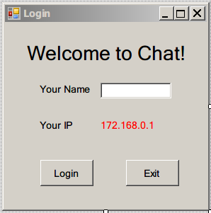

## Main Interface:

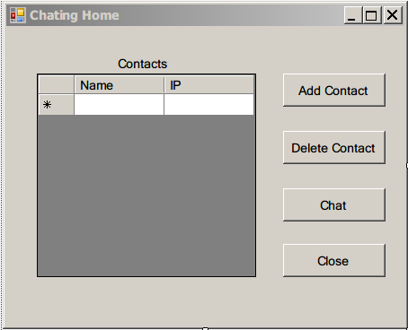

## Add Contact:

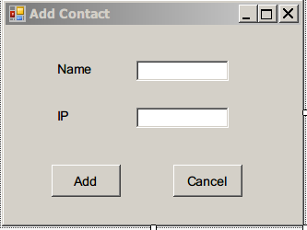

If contact is added

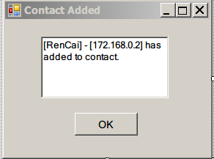

## Chating

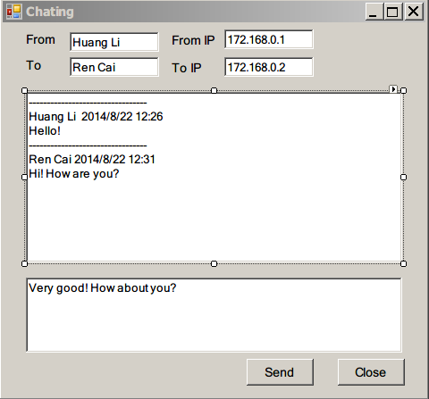

# Class Diagram



# Plan:

